ThermStats: an R package for quantifying surface thermal heterogeneity in assessments of microclimates

Rebecca A. Senior1*§, Jane K. Hill2 and David P. Edwards1

1Department of Animal and Plant Sciences, Alfred Denny Building, University of Sheffield, Western Bank, Sheffield, S10 2TN, UK

2Department of Biology, University of York, Wentworth Way, York, YO10 5DD, UK

\***Corresponding author:** [rebecca.a.senior@gmail.com](mailto:rebecca.a.senior@gmail.com), +44(0)114 2220123 (R.A. Senior)

§ Present address: Woodrow Wilson School of Public and International Affairs and Department of Ecology and Evolutionary Biology, Princeton University, Princeton, New Jersey 08544 USA

**ORCID iDs:** orcid.org/0000-0002-8208-736X (R.A. Senior); orcid.org/0000-0003-1871-7715 (J.K. Hill)

**Key words:** infrared; microclimate; temperature; thermal camera; thermography; thermoregulation.

**Type of paper:** Application

**Word count:** 3206/3000 words

# Abstract

1. Variation in temperature at a fine spatial scale creates critically important microclimates for many organisms. Quantifying thermal heterogeneity at this scale is challenging and, until recently, has been largely restricted to the use of dataloggers to record air temperature. Thermography is becoming an increasingly viable alternative. A single photo from a thermal imaging camera contains thousands of spatially explicit surface temperature measurements, making them ideal for rapidly assessing temperature variation at fine scale.
2. Here, we present an R package – ThermStats – for processing thermal images and other gridded temperature data. The package addresses current constraints on applying thermography in ecology, by speeding up and simplifying the extraction of data from thermal images, and by facilitating the calculation of different metrics of thermal heterogeneity.
3. We demonstrate how ThermStats can be used to capture temperature variation at fine spatial scales in structurally complex habitat, such as tropical rainforest, using two datasets: thermal images collected in the field (~0.5 cm2 resolution), and a temperature layer estimated from LiDAR data (2,500 m2 resolution). ThermStats allows a range of statistics to be calculated that capture both the frequency distribution and spatial patterns of temperature, and functions are designed to accommodate different sampling strategies and data in either matrix or raster format.
4. Our package simplifies the processing of thermal data, and our metrics capture key spatiotemporal temperature trends that underpin physiological, behavioural and demographic responses to environmental change. As such, ThermStats can advance a wide range of studies requiring fine-scale surface temperature data for microclimate investigations.

**253 words**

# Introduction

Temperature variation over scales of mm to m has a central role in the ecology of many species. For small organisms or life stages, this is the scale at which nearly all thermal experiences will occur (Potter, Arthur Woods, & Pincebourde, 2013). Mobile species utilise fine-scale thermal heterogeneity on a daily basis to avoid or exploit extremes of heat. Over longer time periods, climate at this scale (‘microclimate’) can also maximise fitness and thus influence the fine-scale distribution of less mobile species (Maclean, Suggitt, Wilson, Duffy, & Bennie, 2017), allowing species to persist within ‘microrefugia’ where climatic conditions are otherwise unsuitable, and potentially maintaining higher overall biodiversity in thermally heterogenous habitats (Hannah et al., 2014). The same mechanisms underlying fine-scale thermoregulation and thermal microrefugia could temper species’ exposure to global climate change (Scheffers, Evans, Williams, & Edwards, 2014; Suggitt et al., 2018), especially in structurally complex habitats such as tropical rainforests (Scheffers et al., 2017). To understand and predict species’ responses to temperature change we must therefore be able to efficiently capture thermal heterogeneity at fine spatial scales, but there are challenges associated with acquiring and analysing temperature data at this resolution.

The use of temperature dataloggers has been instrumental in advancing the field of thermal ecology (Bramer et al., 2018). However, dataloggers can only record the air temperature in their immediate vicinity, and so must be highly replicated in space and in different microhabitats to capture spatial temperature variation. The temperature recorded by dataloggers is strongly influenced by the use of radiation shields and their construction (Bramer et al., 2018), and even unshielded sensors have weatherproof casing that influence measurements (Bramer et al., 2018). The ‘correct’ way to measure temperature largely depends on what best captures the temperature experienced by the organism of interest (Blonder et al., 2018). The vast majority of terrestrial organisms are very small, flat, or thigmothermic (i.e. thermoregulate via direct contact with a surface), hence surface temperature may be more biologically relevant than free air temperature (e.g. Kaspari, Clay, Lucas, Yanoviak, & Kay, 2015).

Technological advances in recent years have made thermal cameras an increasingly affordable and practical complement to dataloggers (Faye, Rebaudo, Yánez-Cajo, Cauvy-Fraunié, & Dangles, 2016; Scheffers et al., 2017). A single thermal image provides thousands of spatially explicit surface temperature measurements at the mm-cm scale. *The first ecological study to use thermography was in 1977 (Thofelt,* *1977**), and since then there have been approximately 47 additional studies (Supplementary Text S2)*. Clearly thermography is an emerging technique in ecology, spanning studies of mite movement over leaf surfaces (Caillon, Suppo, Casas, Arthur Woods, & Pincebourde, 2014) to detecting mange in wolves (Cross et al., 2016).

To make the most of the wealth of data provided by thermal imagery, ecologists require simple and relevant tools and guidelines. First this requires an understanding of infrared technology and its limitations, which is discussed in detail by Tattersall (2016) and is briefly outlined here (see ‘Step 1: Data collection’). Subsequently, extracting and processing data from thermal images is rarely straightforward, while parameters such as emissivity strongly influence the accuracy of measurements but may not be well understood by the novice user (Bramer et al., 2018). The extraction of data from FLIR thermal cameras specifically was made easier with the development of the Thermimage package (Tattersall, 2017) in R (R Core Team, 2018). However, the package does not directly facilitate processing in batch, nor does it calculate (or suggest) what metrics best capture spatiotemporal temperature variation. Here, we present a novel approach that builds on the functionality of Thermimage to meet the needs of ecologists: allowing hundreds of images to be processed with ease, and summarising data in terms of variables that matter to individual organisms.

The most appropriate metrics to quantify thermal heterogeneity will depend on the taxonomic group and research questions of interest. Temperature varies across time and space in many ways that can easily be captured by thermal images; it is important to exploit the information provided without becoming overwhelmed. Both Shi, Wen, Paull, & Guo (2016) and Faye et al. (2016) provide a useful summary of some important metrics, and Faye et al. (2016) introduce a spatial component by borrowing metrics from landscape ecology, such as Shape Index and Cohesion Index (McGarigal, Cushman, & Ene, 2012). Extending this approach reveals other relevant techniques, such as hot spot analysis (Getis & Ord, 1996) and connectivity (McGuire, Lawler, McRae, & Theobald, 2016). Together this suite of metrics provide a powerful way for ecologists to characterise temperature variation.

Here we introduce the R package ThermStats, which integrates ideas, techniques and metrics from previous work into one simple framework for quantifying thermal hetereogeneity. ThermStats alleviates two key constraints on the application of thermography in ecology:

1. Automates and speeds up the extraction and conversion of raw data from (FLIR) thermal images.
2. Provides a variety of tools to calculate metrics of thermal heterogeneity using any gridded temperature data.

A schematic outline of the package is included in the supplementary vignette (Figure S1). We illustrate the utility of our package using temperature data for the island of Borneo, including thermal images collected in the field using a FLIR thermal camera, and a coarser resolution microclimate layer estimated using LIDAR data (Jucker et al., 2018).

# Functionality

## Step 1: Thermal image collection

High-resolution surface temperature measurements can easily be collected in the field using a handheld thermal camera. We used a FLIR Systems, model E40 camera, which costs ~US$4,000, weighs 825 g, and takes 19,200 measurements (160 x 120 pixels) in a single photo (FLIR, 2016; Scheffers et al., 2017). Various other models are available, including the smaller and more affordable FLIR ONE smartphone attachment at ~US$300, 34.5 g and a resolution of 80 x 60 pixels. As with any field study, the sampling design should aim to achieve sufficient coverage over the study area and over time, such that the images are representative samples of the treatments of interest. For example, a single image of the ground from 1 m away encompasses an area of 0.9 x 1.1 m (1 pixel ≅ 0.5 cm2) using a FLIR E40 camera (FLIR, 2016), and so it may be necessary to take multiple photos in different cardinal directions and at different times of day to effectively represent the temperature of a study plot (Scheffers et al., 2017; Senior, Hill, Benedick, & Edwards, 2018).

Before any data are collected, we recommend users familiarise themselves with the technology (for a thorough review, see Tattersall, 2016). There are various sources of the infrared radiation detected by a thermal camera, but we want to focus only on the radiation emitted by the object of interest, which is a function of its temperature. The amount of radiation emitted by a particular object, for a given temperature, depends on its emissivity. A perfect blackbody has an emissivity of 1, while surfaces that an ecologist is likely to photograph typically have an emissivity from 0.92 (for dry, bare soil; FLIR, 2016) to 0.99 (for green broadleaf forest; Snyder, Wan, Zhang, & Feng, 1998). Additionally, the temperature and relative humidity of the atmosphere and the distance between the object and the camera will affect (1) the amount of emitted radiation that is absorbed by the atmosphere and (2) the amount of background radiation, with some of this also being reflected by the object (reflected apparent temperature).

To accurately quantify surface temperature, environmental parameters (emissivity, reflected apparent temperature, atmospheric temperature, atmospheric relative humidity and object distance) can be set in the camera or defined during data processing (see ‘Step 3: Conversion of raw data’). The benefit of the latter approach is that the user can measure atmospheric temperature and relative humidity concurrently with thermal image collection, and these parameters can then be set individually during image processing. Object distance should be minimised and kept constant where possible. Emissivity can either be estimated from the literature (cf. Scheffers et al., 2017) or sampled in the field (FLIR, 2016). Reflected apparent temperature can also be sampled (FLIR, 2016), although for high emissivities and short object distances, relatively little radiation is reflected and thus apparent temperature can be assumed to equal the atmospheric temperature (Tattersall, 2017). It is recommended that thermal cameras are regularly calibrated (FLIR Systems suggest doing so once per year).

## Step 2: Data extraction

A single thermal photo from a FLIR model E40 camera comprises 160 x 120 pixels, each of which is a unique measurement of received infrared radiation encoded as raw 16-bit values. Data can be extracted into a .csv file using the freely available FLIR Tools software (<https://www.flir.com/products/flir-tools>; cf. Scheffers et al., 2017), although we do not recommend this because it cannot be done in batch, there is less transparency regarding the conversion of raw values to temperature, and for some camera models FLIR Tools uses interpolation to elevate the number of pixels (up to 320 x 240 for a model E40 camera). A quicker and more flexible approach is to use the R package Thermimage (Tattersall, 2017). The function readflirJPG is able to extract all raw data from a FLIR thermal image, and can be implemented in batch using the function batch_extract in our package, ThermStats. For comparison, manual extraction of 275 images took approximately 62 minutes, versus 14 minutes using batch_extract.

## Step 3: Conversion of raw data

The raw values embedded in a FLIR thermal image can be converted to temperature in °C using equations from infrared thermography (FLIR, 2016; Tattersall, 2017). This is made simple by the function raw2temp in Thermimage, which can be implemented in batch in our package using the function batch_convert. Several default values are defined in raw2temp, but the most accurate temperature conversion will be achieved when the environmental parameters, described in Step 1, are defined by the user. Notably, default emissivity is 1, but should realistically take a value between 0.95 and 0.97 (Tattersall, 2017), while relative humidity is highly dependent on habitat and weather conditions. Conversion of raw data also requires various calibration constants that are specific to each camera. These can be retrieved from a thermal image using the Thermimage function flirsettings, which is done automatically by batch_extract.

## Step 4: Calculate metrics of thermal hetereogeneity

### Pixel-level statistics

The most relevant metrics to quantify thermal heterogeneity depend on the particular research questions. The function get_stats takes a single thermal dataset, in the form of a matrix or raster (Hijmans, 2018), and calculates user-defined summary statistics across all pixels. Standard summary statistics could include measures such as mean and standard deviation, but may also include metrics such as thermal richness (the number of unique temperature values) and thermal diversity indices (cf. Faye et al., 2016). Several helper functions are available to implement less standard summary statistics. Based on discussions in Faye et al. (2016) and Shi et al. (2016), we recommend some statistics for use by ecologists in Table 1.

For organisms seeking cooler microclimates under climate warming, the extent to which pixels in an image are connected to cooler pixels could be a proxy for the efficiency of thermoregulatory movements. From a given starting pixel, the greater maximum temperature difference that can be achieved by traversing from hotter to cooler pixels, the more effective local movement is likely to be as a mechanism to avoid excessively high temperatures. This concept of thermal connectivity is based on the landscape-level climate connectivity measure of McGuire et al. (2016), and can be calculated using the function connectivity.

### Patch-level statistics

The function get_stats identifies hot and cold spots in thermal images using a standalone function get_patches. Hot and cold spots are based on the G* variant of the Getis-Ord local statistic (Getis & Ord, 1996), calculated using the spdep package (Bivand & Piras, 2015). The statistic is calculated for individual pixels by comparing the local weighted average of the pixel and its neighbours to the global average. High positive values exceeding the Z-value threshold (defined according to the sample size; Getis & Ord, 1996) are classified as hot spots, and low negative values as cold spots. Several spatial statistics are then calculated to characterise the hot and cold spots (Table 2; cf. Faye et al., 2016). There is an option to return patch outlines as a SpatialPolygonsDataFrame, which can be plotted on the temperature data using plot_patches alongside an (optional) histogram of the temperature distribution (Figure 1).

Table 1: Suggested summary statistics that can be applied by get_stats.

|  |  |
| --- | --- |
| Summary statistic | Description |
| Average temperature | Provides context for all other statistics, and could be used as a measure of the macroclimate for small, surface-dwelling organisms. The median is more robust than the mean to spurious extreme values that can sometimes arise in thermal images. |
| Temperature extremes | While more rarely encountered, extreme values can be more significant to organisms, for example by exceeding upper thermal limits or by providing cool refugia from average conditions. The difference between extremes provides a measure of thermal diversity/stability (Shi et al., 2016), while the difference between extremes and average temperature provides a measure of the potential for thermal buffering. Again, we suggest the 5th and 95th percentiles are more robust to spurious extreme values than the minimum and maximum (respectively). |
| Temperature variability | Over space and time, the standard deviation or coefficient of variation of temperature represents another measure of thermal stability (Shi et al., 2016), which may be particularly significant for organisms requiring constant temperatures, e.g. juveniles with a lower capacity for thermoregulatory behaviours. In contrast, for other mobile organisms – particularly ectotherms – high thermal diversity is likely to maximise opportunities for thermoregulation. |
| Thermal diversity indices | Capture both the richness and evenness of different temperatures. Similar to temperature variability, the biological relevance of this measure is through its influence on the necessity and potential for thermoregulation. As discussed by Faye et al. (2016), Shannon’s thermal diversity index quantifies how reliably one can predict the temperature of a pixel sampled at random from the temperature data. Simpson’s thermal diversity index is similar; it captures the likelihood of two pixels being the same temperature (or temperature class) when sampled at random. |
| Thermal connectivity | Calculated for each pixel as the potential for temperature change, which is the maximum temperature difference that can be achieved by traversing a gradient of hotter to cooler pixels. Adapted from McGuire et al. (2016). |

Table 2: Patch statistics calculated for hot and cold spots by the function get_stats.

|  |  |  |
| --- | --- | --- |
| Patch statistic | Description | Biological relevance |
| Area (absolute) | Total number of pixels | Larger or more numerous microclimates increase opportunities for thermoregulation. |
| Area (proportion) | Proportion of all pixels which are inside hot/cold spots | Where a greater proportion of pixels fall inside microclimates there is likely to be higher thermal diversity. |
| Abundance | Number of distinct hot/cold spots | More numerous microclimates increase opportunities for thermoregulation. |
| Density | Number of hot/cold spots per unit area | Larger microclimates increase opportunities for thermoregulation. |
| Shape Index | Irregularity in shape of hot/cold spots, with 1 being perfectly regular (i.e. a square; McGarigal et al., 2012) | More irregular microclimates could be less thermally stable but easier to locate, because of the greater proportion of edge. |
| Aggregation Index | Degree of clustering in space of hot/cold spots, with zero representing no clustering (He, DeZonia, & Mladenoff, 2000) | Dispersed, non-clustered microclimates are easier for animals to locate (Sears et al., 2016). |
| Patch Cohesion Index | Physical connectedness of hot/cold spots (Schumaker, 1996) | More connected microclimates may facilitate more efficient travel. |

### Multiple images

We assume that for most users the spatial unit of replication will comprise multiple thermal images. In this case, the user can specify a grouping variable in stats_by_group. Matrices from each group will be bound together and get_stats applied over the combined matrix. Processing times increase with more or larger images, although this can be managed by disabling the calculation of hot and cold spots or of thermal connectivity (patches = FALSE and connectivity = FALSE), since these are the most computationally intensive statistics. We assume that images are not adjacent in space, and therefore pad matrices with NA values before binding. Table S2 gives an example of the output from stats_by_group. Users can also average across repeated samples of the same area using average_by_group, the output of which can be passed directly to stats_by_group. Raster stacks are generally quicker to process, and can be created from a list of matrices using stack_imgs. All of the examples that follow were run on a 64-bit Windows 10 machine with an Intel Core i7-4600U @ 2.10GHz processor and 8GB RAM.

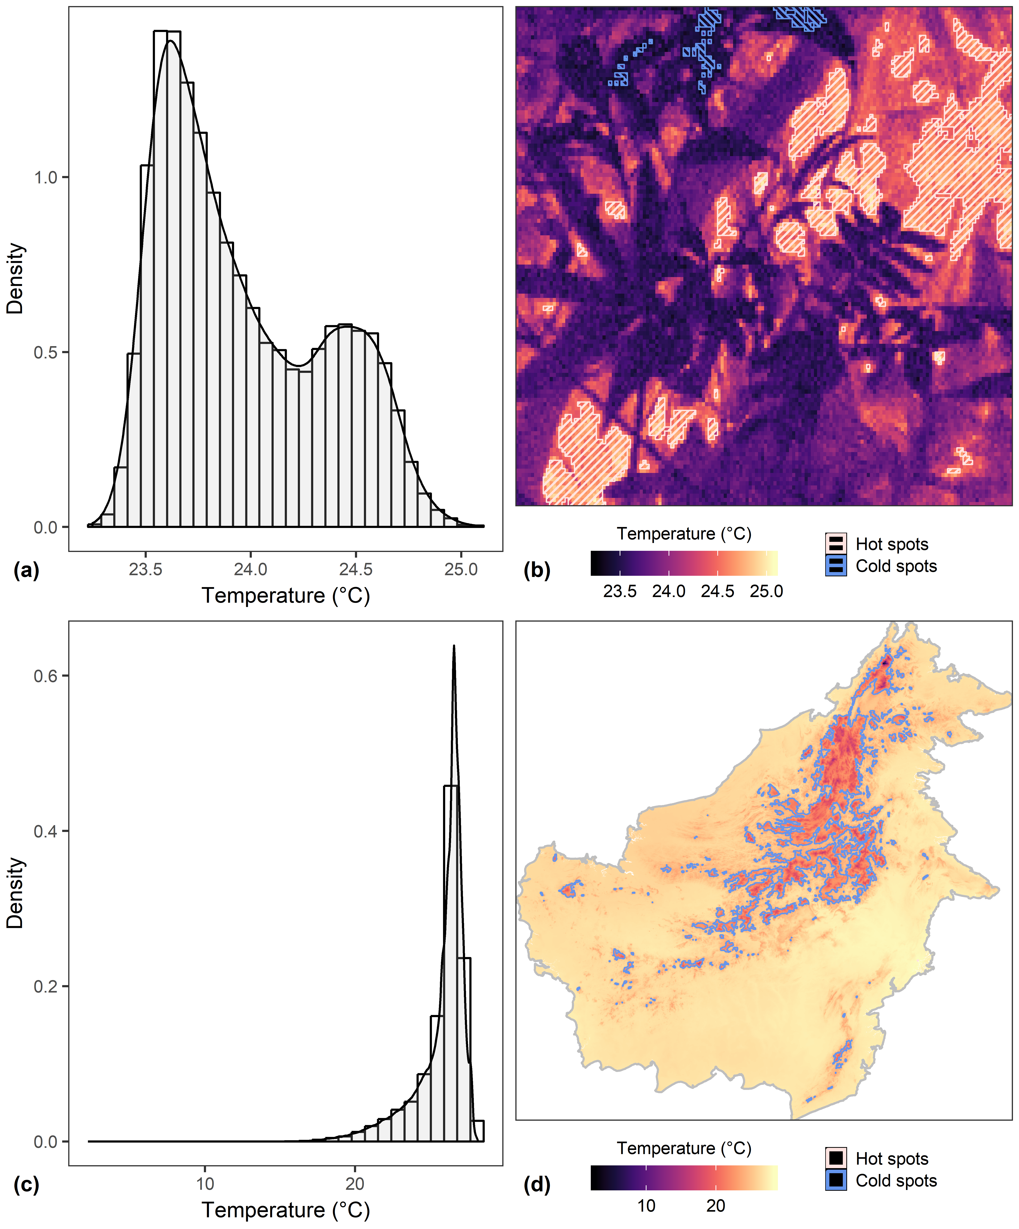

Figure 1: Examples of temperature frequency distribution (left column) and spatial distribution (right column) for temperature data from a thermal image (top row) and from WorldClim2 (bottom row; Fick & Hijmans, 2017). Pixels are shaded from cold (black) to hot (beige). Clusters of extreme values were identified by calculating the G* variant of the Getis-Ord local statistic for each pixel (Getis & Ord, 1996), with high positive values assigned to hot spots (outlined in pink) and low negative values to cold spots (outlined in blue).

# Example applications

## Thermal heteorogeneity over time in logged and unlogged forests

We demonstrate a typical workflow using fine-scale temperature data collected in the field with a FLIR thermal camera. To investigate how thermal heterogeneity varies over time and with selective logging, we sampled surface temperature in a large area of contiguous forest in Malaysian Borneo in the years 2014 and 2015, using a FLIR Systems model E40 thermal camera. In both years, photos were taken at points spaced every 125 m along existing transects, with six transects in undisturbed primary forest (Danum Valley Conservation Area; 4°57045.2“N, 117°48010.4”E), and six transects in adjacent forest that had been commercially selectively logged twice between 1987 and 2007 (Ulu Segama-Malua Forest Reserve, 4°57042.8“N, 117°56051.7”E). Points were sampled repeatedly from the coolest to the hottest part of the day (05:00-14:30 h). In each sampling event, thermal images were taken in four orthogonal directions, with the camera held at breast height and pointing 45° downwards (relative to the ground). In total we collected 2,972 photos across 144 points. For full details see Scheffers et al. (2017) and Senior et al. (2018).

Data were extracted using batch_extract and converted using batch_convert (see Supplementary Text S1 for a full worked example in the package vignette). We focused on the following summary statistics from Table 1: median temperature; Shannon Diversity Index; upper temperature range (95th percentile - median); and lower temperature range (median - 5th percentile). For hot and cold spots separately, we calculated the following spatial statistics (Table 2): average area per patch (total area divided by number of patches, to correct for points with missing photos); average number of patches per unit area (density); Shape Index; and Aggregation Index. We used stats_by_group to calculate each metric across all four photos taken each time a point was sampled (one photo in each direction).

To model the various thermal heterogeneity metrics against time of day and forest type (categorical: primary or logged) we fit Generalized Additive Mixed Effects Models (GAMMs), using the gamm4 package (Wood & Scheipl, 2017) in R. All measures of thermal heterogeneity were comparable between primary and unlogged forest (P > 0.05; Figure 2), but varied from the coolest time of day (~06:00 hr) to the hottest (~12:30 hr). Of particular note is the peak in thermal diversity (Shannon Diversity Index) at noon, and the different temporal patterns of hot spots (median temperature: 25°C) compared to cold spots (median temperature: 27°C).

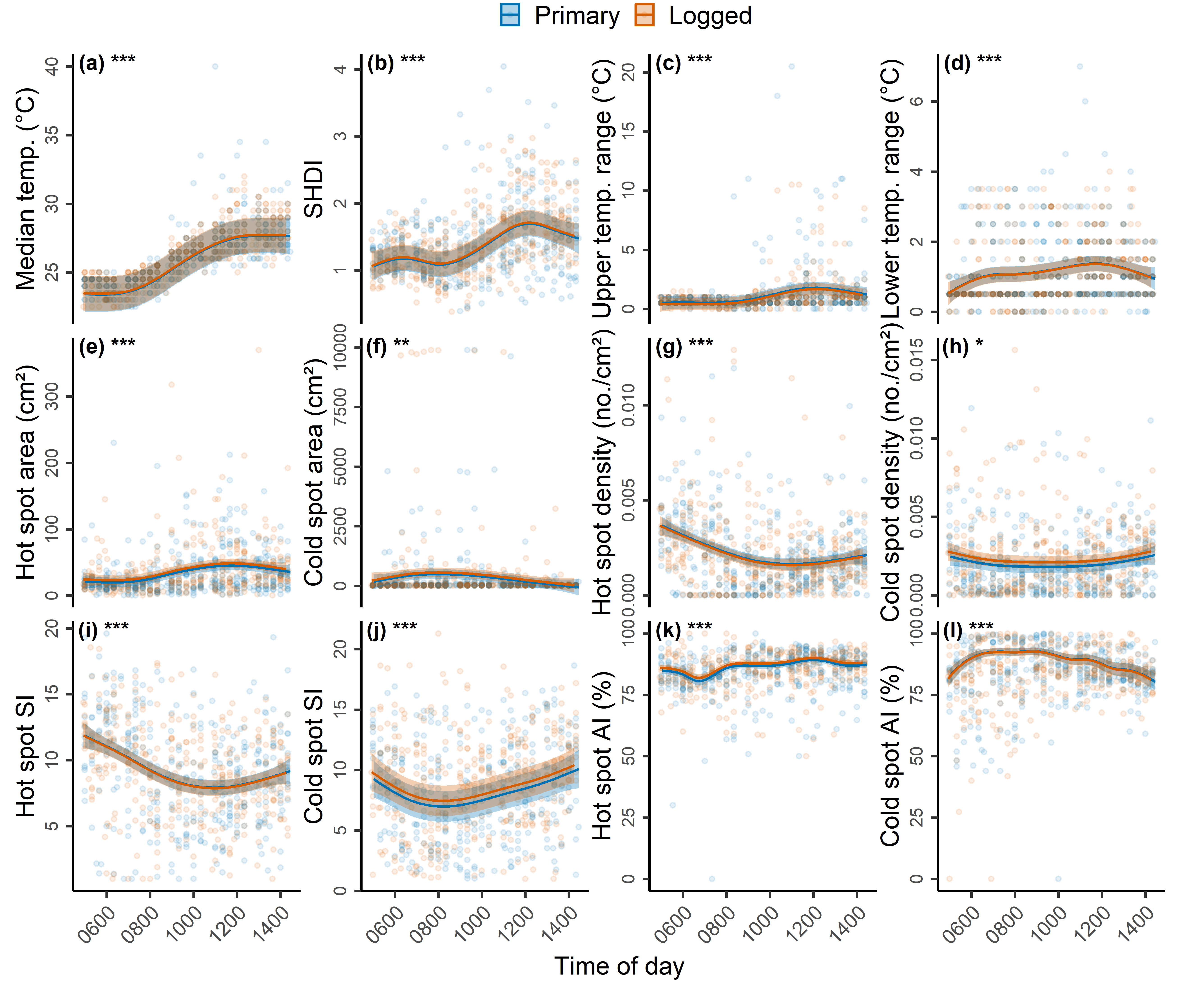

Figure 2: Trends in various measures of thermal heterogeneity over the day (06:00-14:30 hrs) for fine-scale temperature data collected using a thermal camera in primary (blue) and logged forests (orange). From left to right and top to bottom, the metrics are: median temperature (a); thermal Shannon Diversity Index (b); 95th percentile minus median temperature (c); 5th percentile minus median temperature (d); the average area (cm2) per hot spot (e); the average area (cm2) per cold spot (f); the number of hot spots per unit area (g); the number of cold spots per unit area (h); the Shape Index *(SI)* of hot spots (i); the Shape Index *(SI)* of cold spots (j); the Aggregation Index *(AI)* of hot spots (k); and the Aggregation Index *(AI)* of cold spots (l). Solid lines are model-predicted values with 95% confidence intervals. Semi-transparent background points represent the raw data. Statistically significant differences are indicated by asterisks: 0.01 < P < 0.05 (*); 0.001 < P < 0.01 (**) and P < 0.0001 (***).

## Averaging over repeated images

Averaging across repeated images of the same area could help to reduce unwanted variation, such as that introduced by the camera or photographer. In this example, thermal images were collected at nine points (‘spatial replicate’) spaced along existing transects in undisturbed primary forest (Danum Valley Conservation Area; 4°57045.2“N, 117°48010.4”E). Each point was visited at two different times (‘temporal replicate’) on the same day. On each visit to a point, between three and five photographs were taken sequentially (‘camera replicate’) between thee and five times, with the photographer moving away each time and resetting their position (‘photographer replicate’). To smooth variation largely introduced by the camera and photographer, we averaged within temporal replicates using the function average_by_group. The R package rasterVis (Perpiñán & Hijmans, 2018) is ideal for visualising these data; we use bwplot to display the temperature distribution across the average rasters produced by average_by_group for each temporal replicate (Figure 3).

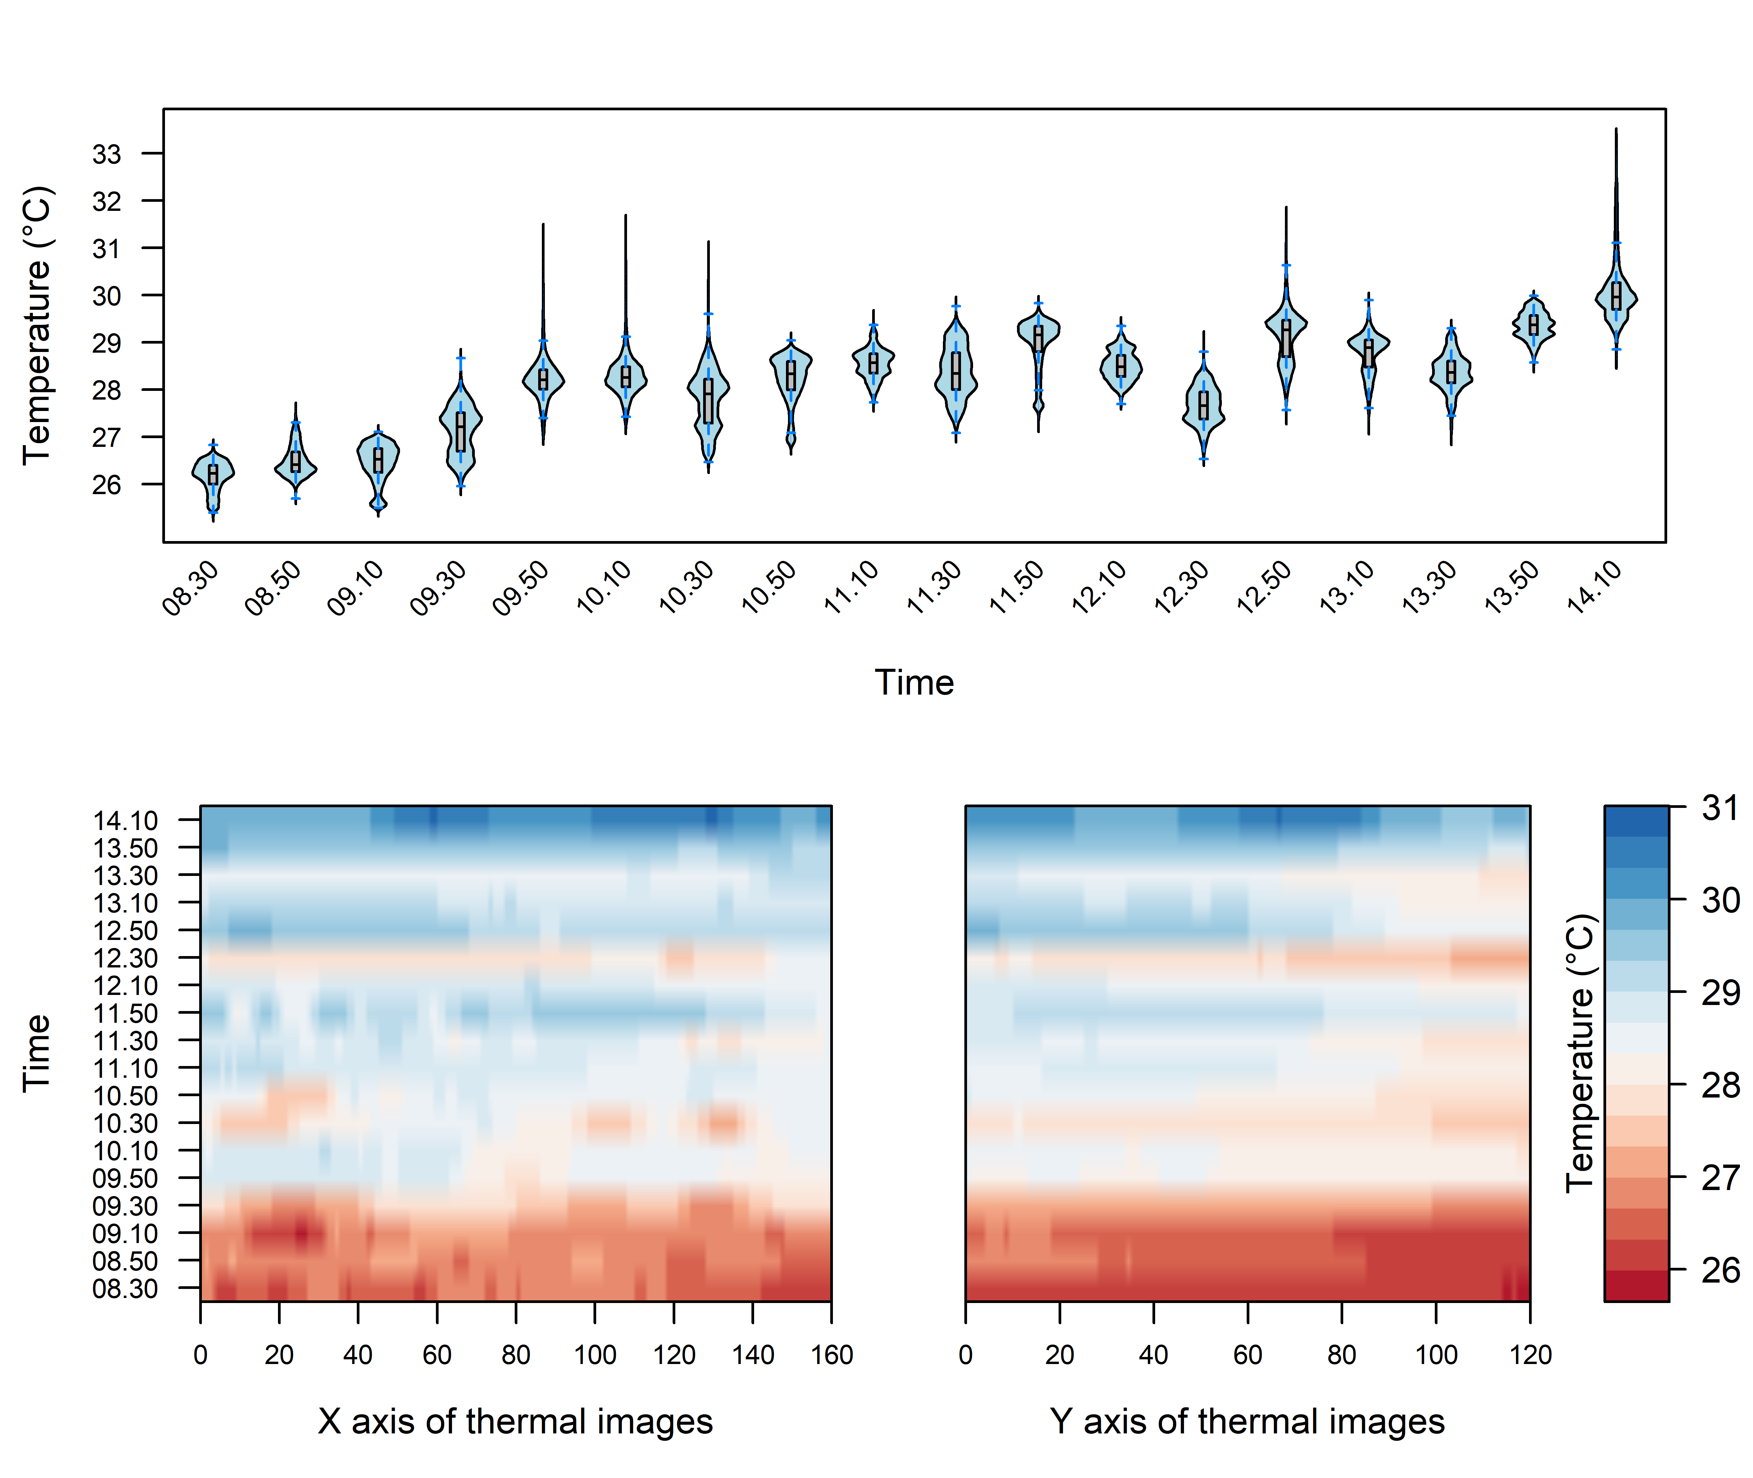

Figure 3: Violin plots of temperature distribution across the raster of each distinct replicate in time. Each datapoint represents one pixel of the raster. Each raster is the average of multiple thermal images collected at the same time and location, averaged within temporal replicates using the function average_by_group.

## Using other gridded temperature data

Analytical functions in ThermStats are designed for any gridded temperature data. We illustrate this using a mean annual temperature layer (50 x 50 m resolution) estimated from canopy structure and topographic variables measured using LiDAR (Jucker et al., 2018). The layer encompasses forest and oil palm plantation within the Stability of Altered Forest Ecosystems (SAFE) project (Ewers et al., 2011). We created a raster stack with one layer for cells inside the plantation boundary and one for cells outside, and used stats_by_group to identify hot and cold spots within each layer. The patch characteristics calculated by stats_by_group include upper and lower quantiles and the median, which together characterise the temperature distribution and can be used to construct boxplots (Figure 4).

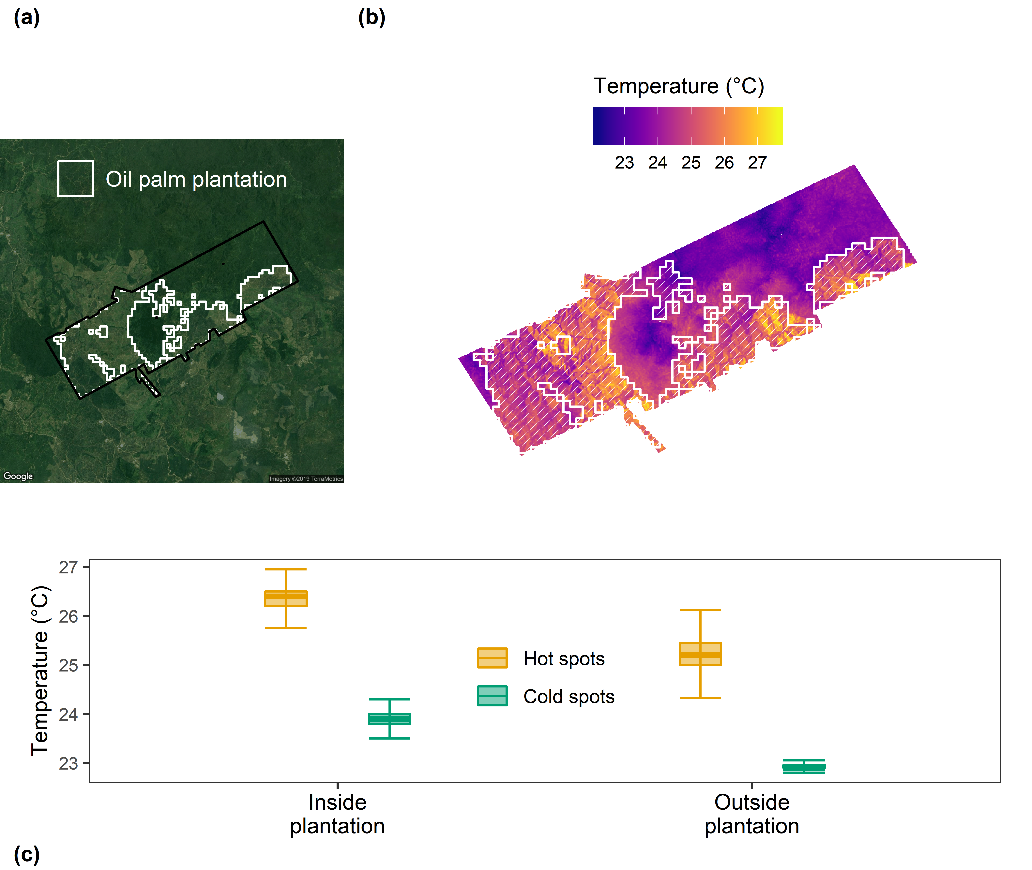

Figure 4: Panel (a) depicts variation in modelled mean annual temperature in the Stability of Altered Forest Ecosystems (SAFE) project (Ewers et al., 2011; Jucker et al., 2018), overlaid with the boundary of oil palm plantations (black outline). Panel (b) shows the temperature distribution of hot spots (left) and cold spots (right), inside (orange) and outside (green) plantations.

# Concluding remarks

Our R package presents users with a simple protocol for utilising thermography within ecology. The extraction of data from FLIR thermal cameras is made faster and easier, and for any gridded temperature data the package facilitates the calculation of different, biologically-relevant metrics of thermal heterogeneity (Faye et al., 2016; Shi et al., 2016; Senior et al., 2018).

It is important to consider the strengths and weaknesses of thermography when deciding on the most appropriate methodology to answer research questions of interest. Thermal cameras cannot directly measure sub-surface temperatures and are not as well suited for capturing temporal variation compared with dataloggers (Senior et al., 2018). Although affordable smartphone attachments are now available, thermal cameras may still be more expensive than dataloggers (depending on the quantity of dataloggers required), and can be sensitive to extreme weather conditions common to regions such as the tropics and arctic (FLIR, 2016). Bramer et al. (2018) is an excellent resource for ecologists seeking best practice for using dataloggers; we intend that our study and the references herein offer a similar resource for ecologists using thermography.

Fine-scale temperature variation across space and time has a huge influence on species’ ecology, which will become increasingly pertinent as average temperatures rise under global climate warming. We showcase how our R package and framework can be used to quantify thermal heterogeneity using data at a fine spatial scale, collected using a FLIR thermal camera or modelled using remotely sensed data. By simplifying and streamlining the processing of increasingly available thermal imagery, our approach enables researchers to more readily address important issues in ecology and conservation.

# Code availability

The R package ThermStats can be downloaded from GitHub: <https://github.com/rasenior/ThermStats>. Bug reports and suggested enhancements can be submitted to: <https://github.com/rasenior/ThermStats/issues>.

# Acknowledgements

Thanks to Tommaso Jucker for providing the modelled mean annual temperature layer, and to Manoela S. Machado Mollinari for helpful discussions. R.A.S. was funded by a NERC studentship through the ACCE (Adapting to the Challenges of a Changing Environment) Doctoral Training Partnership (Grant No. NE/L002450/1).

# Author contributions

R.A.S. conceived the study. R.A.S., D.P.E., and J.K.H developed the methods. R.A.S. wrote the R package and performed statistical analyses. R.A.S. wrote the first draft of the manuscript, with contributions from D.P.E. and J.K.H.

# References

Bivand, R., & Piras, G. (2015). Comparing Implementations of Estimation Methods for Spatial Econometrics. *Journal of Statistical Software*, *63*, 1–36.

Blonder, B., Both, S., Coomes, D. A., Elias, D., Jucker, T., Kvasnica, J., … Svátek, M. (2018). Extreme and Highly Heterogeneous Microclimates in Selectively Logged Tropical Forests. *Frontiers in Forests and Global Change*, *1*. doi:[10.3389/ffgc.2018.00005](https://doi.org/10.3389/ffgc.2018.00005)

Bramer, I., Anderson, B. J., Bennie, J., Bladon, A. J., De Frenne, P., Hemming, D., … Gillingham, P. K. (2018). *Chapter Three - Advances in Monitoring and Modelling Climate at Ecologically Relevant Scales*. (D. A. Bohan, A. J. Dumbrell, G. Woodward, & M. Jackson, Eds.) (Vol. 58, pp. 101–161). Academic Press. doi:[10.1016/bs.aecr.2017.12.005](https://doi.org/10.1016/bs.aecr.2017.12.005)

Caillon, R., Suppo, C., Casas, J., Arthur Woods, H., & Pincebourde, S. (2014). Warming decreases thermal heterogeneity of leaf surfaces: Implications for behavioural thermoregulation by arthropods. *Functional Ecology*, *28*(6), 1449–1458. doi:[10.1111/1365-2435.12288](https://doi.org/10.1111/1365-2435.12288)

Cross, P. C., Almberg, E. S., Haase, C. G., Hudson, P. J., Maloney, S. K., Metz, M. C., … Smith, D. W. (2016). Energetic costs of mange in wolves estimated from infrared thermography. *Ecology*, *97*(8), 1938–1948. doi:[10.1890/15-1346.1](https://doi.org/10.1890/15-1346.1)

Ewers, R. M., Didham, R. K., Fahrig, L., Ferraz, G., Hector, A., Holt, R. D., … Turner, E. C. (2011). A large-scale forest fragmentation experiment: The Stability of Altered Forest Ecosystems Project. *Philosophical Transactions of the Royal Society of London B: Biological Sciences*, *366*(1582), 3292–3302. doi:[10.1098/rstb.2011.0049](https://doi.org/10.1098/rstb.2011.0049)

Faye, E., Rebaudo, F., Yánez-Cajo, D., Cauvy-Fraunié, S., & Dangles, O. (2016). A toolbox for studying thermal heterogeneity across spatial scales: From unmanned aerial vehicle imagery to landscape metrics. *Methods in Ecology and Evolution*, *7*(4), 437–446. doi:[10.1111/2041-210X.12488](https://doi.org/10.1111/2041-210X.12488)

Fick, S. E., & Hijmans, R. J. (2017). WorldClim 2: New 1-km spatial resolution climate surfaces for global land areas. *International Journal of Climatology*, *37*(12), 4302–4315. doi:[10.1002/joc.5086](https://doi.org/10.1002/joc.5086)

FLIR. (2016). User’s manual FLIR Exx series. Retrieved from <http://flir.custhelp.com/app/account/fl_download_manuals>

Getis, A., & Ord, J. K. (1996). Local spatial statistics: An overview. *Spatial Analysis: Modelling in a GIS Environment*, *374*, 261–277.

Hannah, L., Flint, L., Syphard, A. D., Moritz, M. A., Buckley, L. B., & McCullough, I. M. (2014). Fine-grain modeling of species’ response to climate change: Holdouts, stepping-stones, and microrefugia. *Trends in Ecology & Evolution*, *29*(7), 390–397. doi:[10.1016/j.tree.2014.04.006](https://doi.org/10.1016/j.tree.2014.04.006)

He, H. S., DeZonia, B. E., & Mladenoff, D. J. (2000). An aggregation index (AI) to quantify spatial patterns of landscapes. *Landscape Ecology*, *15*(7), 591–601. doi:[10.1023/A:1008102521322](https://doi.org/10.1023/A:1008102521322)

Hijmans, R. J. (2018). Raster: Geographic data analysis and modeling. Retrieved from <https://CRAN.R-project.org/package=raster>

Jucker, T., Hardwick, S. R., Both, S., Elias, D. M. O., Ewers, R. M., Milodowski, D. T., … Coomes, D. A. (2018). Canopy structure and topography jointly constrain the microclimate of human-modified tropical landscapes. *Global Change Biology*, *0*(0). doi:[10.1111/gcb.14415](https://doi.org/10.1111/gcb.14415)

Kaspari, M., Clay, N. A., Lucas, J., Yanoviak, S. P., & Kay, A. (2015). Thermal adaptation generates a diversity of thermal limits in a rainforest ant community. *Global Change Biology*, *21*(3), 1092–1102. doi:[10.1111/gcb.12750](https://doi.org/10.1111/gcb.12750)

Maclean, I. M. D., Suggitt, A. J., Wilson, R. J., Duffy, J. P., & Bennie, J. J. (2017). Fine‐scale climate change: Modelling spatial variation in biologically meaningful rates of warming. *Global Change Biology*, *23*(1), 256–268. doi:[10.1111/gcb.13343](https://doi.org/10.1111/gcb.13343)

McGarigal, K., Cushman, S. A., & Ene, E. (2012). FRAGSTATS v4: Spatial pattern analysis program for categorical and continuous maps. Retrieved from <http://www.umass.edu/landeco/research/fragstats/fragstats.html>

McGuire, J. L., Lawler, J. J., McRae, B. H., & Theobald, D. M. (2016). Achieving climate connectivity in a fragmented landscape. *Proceedings of the National Academy of Sciences*, *113*(26), 7195–7200. doi:[10.1073/pnas.1602817113](https://doi.org/10.1073/pnas.1602817113)

Perpiñán, O., & Hijmans, R. (2018). rasterVis. Retrieved from <http://oscarperpinan.github.io/rastervis/>

Potter, K. A., Arthur Woods, H., & Pincebourde, S. (2013). Microclimatic challenges in global change biology. *Global Change Biology*, *19*(10), 2932–2939. doi:[10.1111/gcb.12257](https://doi.org/10.1111/gcb.12257)

R Core Team. (2018). R: A Language and Environment for Statistical Computing. Vienna, Austria: R Foundation for Statistical Computing. Retrieved from <https://www.R-project.org/>

Scheffers, B. R., Edwards, D. P., Macdonald, S. L., Senior, R. A., Andriamahohatra, L. R., Roslan, N., … Williams, S. E. (2017). Extreme thermal heterogeneity in structurally complex tropical rain forests. *Biotropica*, *49*(1), 35–44. doi:[10.1111/btp.12355](https://doi.org/10.1111/btp.12355)

Scheffers, B. R., Evans, T. A., Williams, S. E., & Edwards, D. P. (2014). Microhabitats in the tropics buffer temperature in a globally coherent manner. *Biology Letters*, *10*(12), 20140819. doi:[10.1098/rsbl.2014.0819](https://doi.org/10.1098/rsbl.2014.0819)

Schumaker, N. H. (1996). Using Landscape Indices to Predict Habitat Connectivity. *Ecology*, *77*(4), 1210–1225. doi:[10.2307/2265590](https://doi.org/10.2307/2265590)

Sears, M. W., Angilletta, M. J., Schuler, M. S., Borchert, J., Dilliplane, K. F., Stegman, M., … Mitchell, W. A. (2016). Configuration of the thermal landscape determines thermoregulatory performance of ectotherms. *Proceedings of the National Academy of Sciences*, *113*(38), 10595–10600. doi:[10.1073/pnas.1604824113](https://doi.org/10.1073/pnas.1604824113)

Senior, R. A., Hill, J. K., Benedick, S., & Edwards, D. P. (2018). Tropical forests are thermally buffered despite intensive selective logging. *Global Change Biology*, *24*(3), 1267–1278. doi:[10.1111/gcb.13914](https://doi.org/10.1111/gcb.13914)

Shi, H., Wen, Z., Paull, D., & Guo, M. (2016). A framework for quantifying the thermal buffering effect of microhabitats. *Biological Conservation*, *204*, 175–180. doi:[10.1016/j.biocon.2016.11.006](https://doi.org/10.1016/j.biocon.2016.11.006)

Snyder, W. C., Wan, Z., Zhang, Y., & Feng, Y.-Z. (1998). Classification-based emissivity for land surface temperature measurement from space. *International Journal of Remote Sensing*, *19*(14), 2753–2774. doi:[10.1080/014311698214497](https://doi.org/10.1080/014311698214497)

Suggitt, A. J., Wilson, R. J., Isaac, N. J. B., Beale, C. M., Auffret, A. G., August, T., … Maclean, I. M. D. (2018). Extinction risk from climate change is reduced by microclimatic buffering. *Nature Climate Change*, 1. doi:[10.1038/s41558-018-0231-9](https://doi.org/10.1038/s41558-018-0231-9)

Tattersall, G. J. (2016). Infrared thermography: A non-invasive window into thermal physiology. *Comparative Biochemistry and Physiology Part A: Molecular & Integrative Physiology*, *202*, 78–98. doi:[10.1016/j.cbpa.2016.02.022](https://doi.org/10.1016/j.cbpa.2016.02.022)

Tattersall, G. J. (2017). Thermimage: Thermal Image Analysis. Retrieved from <https://CRAN.R-project.org/package=Thermimage>

Thofelt, L. (1977). Thermographic Field Studies on Leaf Temperature. *Oikos*, *29*(1), 180–185. doi:[10.2307/3543311](https://doi.org/10.2307/3543311)

Wood, S., & Scheipl, F. (2017). gamm4: Generalized additive mixed models using ’mgcv’ and ’lme4’. Retrieved from <https://CRAN.R-project.org/package=gamm4>